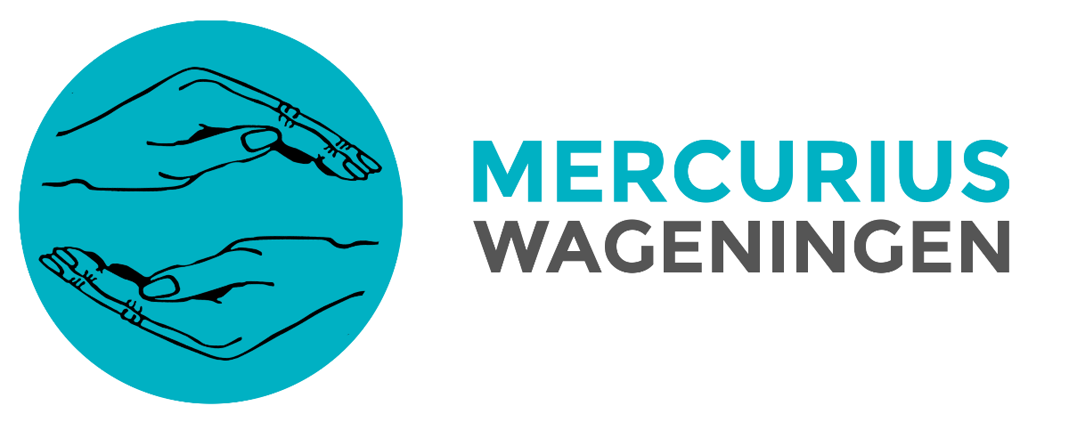
Policy Mercurius Wageningen
September 2020 - March 2021
“Omnia mutantur, nos et mutamur in illis”
– ‘All things change, and we change with them’

Mission
“To enrich the student days of our members
by encouraging personal development in
professional, educational and social field.”
Vision
“In a rapidly changing labour market in which differentiating yourself becomes increasingly important, we will be there for our members in an accessible way to prepare them for a successful future by offering activities in professional, educational and social fields during their student days. Our ambition is to have a critical look at the functioning of the association, to optimise her performance and thereby ensure continuity of Mercurius Wageningen.”

September 2020
Elsa Kuik President
Sophie van Bon Secretary/Vice-President
Lukas Jannink Treasurer
Esther van Seters Director of Marketing
Wessel Reusken Director of Education
Noah van Blaaderen Director of Human Resources
Carlijn Oskam Director of Public Relations

Index
Preface 3
General 4
Membership fee reduction 4
Education 5
Educative activities 5
Sustainability 5
Social 6
Member lunches 6
Committee integration 6
Professional 7
Modernisation 7
Vacancies & Internships 7
Professional Committee 7
Alumni integration 8
Addendum 9

Preface
This policy document is written by the Mercurius Wageningen board of September 2020 until March 2021. This policy document describes the objectives and actions this board focuses on in the upcoming academic half year of September 2020 until March 2021. This board will be committed to the implementation of the policy to get closer to our vision.
In March 2020, the COVID-19 pandemic broke out. This pandemic had impactful, unfortunate consequences for Mercurius Wageningen during the past half year. Unfortunately, COVID-19 is still present and it is uncertain when the pandemic will be over. Mercurius Wageningen will have to be alert and flexible in order to adapt to the complex situation. The committees and the board will do their best to organise as many activities in real life as possible, taking into account the rules of the RIVM and WUR. The aim of the board of 2020-2021 is to increase integration between members, committees and the board.

If activities in real life will not be possible due to COVID-19, the board will look into the possibility of organising activities online. Therefore, one of the goals of the Mercurius Wageningen Board 2020-2021 is to invest in modernisation. Another goal of the board of 2020-2021 is to continue sustainable development.
The following year will be about the realisation of Mercurius Wageningen as a study association which supports her members from the Bachelor Economics and Governance, Bachelor Management and Consumer Studies and the Master Management, Economics and Consumer Studies. This support is realised by focussing on the professional, educational and social aspects that matter to our students. A large number of existing policy plans from previous boards will be continued and further developed upon. This policy is divided into three parts, to mention: Education, Social and Professional.
Because of all uncertainty regarding COVID-19, all activities described below in this policy are subject to change.

General
Membership fee reduction
Due to COVID-19, a lot of activities could not take place and members barely saw each other in real life. The past half year, members have missed a lot of activities and it is uncertain if there will be activities in real life soon. For these reasons, the board has decided to reduce the membership fee for once, from 10 euros to 7 euros for the coming year.

Education

Educative activities
Mercurius Wageningen strives for organising two educative evenings the coming year. During these evenings, speakers will teach members about study related subjects. One evening will be about study related subjects in the educational field suitable for the studies Economics and Governance, Management and Consumer studies and Management, Economics and Consumers studies. During the other evening, members will be taught about study skills. The board will consider collaboration with the study advisors when organising these evenings. In case the educative evenings will not be possible due to COVID-19, Mercurius Wageingen will offer their members online courses. In this way, members can educate themselves on different subjects related to the studies Economics and Governance, Management and Consumer studies and Management, Economics and Consumers studies. Furthermore, organising these educational activities will make the Academic Committee more attractive for members to join.

Sustainability
As Wageningen is known for its high focus on sustainability, Mercurius Wageningen will continue to contribute to sustainable developments. The upcoming year, there will be an educational focus on sustainability. The board is going to teach members about sustainability. In each newsmail, advice will be given regarding sustainability. There will also be a possibility for members to send their own ideas about sustainability to the board, so the board can show these ideas to other members via the newsmail. In this way, Mercurius Wageningen teaches members to act more sustainable in their daily lives.

Furthermore, the board will create an inventory list of all supplies in ‘t Hok, which committees can use for their activities. This inventory list will give an overview of all supplies for activities, this should lead to less and therefore there will be less unnecessary purchases when organising activities for members. There will be less waste, because it is clear for all committees and board members how much and which supplies are what kind of supplies there is already available. The inventory list will be online and will be updated by the watching-over board members.

Social

Member lunches
The board thinks it is still important to create a strong bond between the board and the members of the association. Therefore, the board strives for organising member lunches every period. If the lunches cannot take place in the way they used to, due to COVID-19, the board will look into the possibilities of organising the member lunches in small groups outside or at an external location and according to all the rules of the RIVM. In order to attract more active committee members, Mercurius Wageningen will try to combine the introduction of committees with member lunches. This means committee members will attend some member lunches to socialize and introduce members to the committees of Mercurius Wageningen. In this way, members will meet each other, the board and committee members in an informal way. Simultaneously, the member lunches will create a good opportunity for members to join a committee. In case committee members join the member lunches, information about which committees attend the lunches, will be promoted on our social media channels and the website. In this way, Mercurius Wageningen communicates clearly to members what they can expect during these lunches.

Committee integration
Committees are of great importance for the association, Mercurius Wageningen could not exist without them. In order to let the committees integrate with each other and the board, the Committee Weekend en the beercantus will be organised. Normally, the Committee Weekend takes place in February and the beercantus takes place in the sixth period. Due to COVID-19, the Committee Weekend has been postponed. This year, the board will continue to prepare for the weekend. Mercurius Wageningen wants to see if it is possible to bring forward the beercantus to february and to postpone the committee weekend to the sixth period, so we still can do both activities in times of COVID-19. The Weekend Committee will be established which will help the director of Human Resources to organise the weekend.

Because it is uncertain whether both the Committee Weekend and beer cantus can continue to take place due to COVID-19, the board will look into the possibilities of organising a COVID-19 proof activity for the integration of committees or another way to thank the committee members.

Professional

Modernisation
Especially in times of COVID-19, a well-functioning online environment is of utmost importance. Therefore, Mercurius Wageningen is going to invest in modernisation. First of all, Mercurius Wageningen wants to look into the possibilities of organising activities online. The board will consider purchasing a premium version of an online meeting platform on which activities can be organised.
Secondly, Mercurius Wageningen is going to work on the new website and to make the new website operate even more properly. In order to let the website remain up-to-date in the long term, the board is going to look into the possibilities of frequent website maintenance.
Next, the board will examine the possibilities of creating a webshop on the website in order to allow members to buy merchandise products of Mercurius Wageningen. In this way, the association will reach more members to buy merchandise products and the products will be available throughout the whole year.
When the website is up and running, the board aims for gaining insight into the possibilities of creating a Mercurius Wageningen app which members can download on their phone. A Mercurius Wageningen app will make it much easier for members to sign up for activities or to check recent news messages. An app will increase the accessibility of Mercurius Wageningen and possibly make members more active. Before launching the app, it is important to create an overview of the pros and cons of an app, to find out how other study and student associations are dealing with it and to find out whether the app can be linked to the website.

Vacancies & Internships
Mercurius Wageningen is going to work on the vacancies & internships database and make it more interesting for companies as well as students. The aim of this is to increase the range of vacancies and internships for our members and to create more matches between companies and students. Mercurius Wageningen will consider collaboration with study advisors in order to create a larger vacancies and internships range. A possible process to reach this goal is the “No cure no pay principle”. This means Mercurius Wageningen links interested students with companies providing internships and vacancies via the website. If the company gains an intern or employee via Mercurius Wageningen, the company has to pay a fee to Mercurius Wageningen. Other possibilities of increasing the range of vacancies and internships will also be examined. This process will be executed by the Director of Public Relations, who will be supported by the Acquisition Committee.

Professional Committee
Mercurius Professional is the committee which focuses mainly on end-bachelor and master students. Often Mercurius Professional is seen as a separate association as it is the only committee which does not end with “Committee”. This potentially creates confusion about where this committee actually stands for. Therefore, the board and the committee have been looking at the possibilities of changing the name. The committee Mercurius Professional has agreed to the name change from Mercurius Professional to Professional Committee. So from now on, the committee will be called “Professional Committee”.

Alumni integration
Mercurius Wageningen aims for organising integration gatherings with alumni. The aim of this is to let alumni integrate with current members of Mercurius Wageningen. Alumni will be invited to come to Wageningen and talk about their career experiences to small groups of students. In this way, alumni can teach students about career orientation and students can directly ask questions about career related matters. The board wants to organise these gatherings in cooperation with the study advisors and the Alumni Committee. If it is not possible to organise this event in real life, organising it online could be a solution. The main focus will be on integrating master students with alumni, but the board will also consider making the event accessible for bachelor students.

Addendum
In this policy, the plans for the academic year of 2020-2021 are stated. Our aphorism “Omnia mutantur, nos et mutamur in illis” – ‘All things change, and we change with them’ was central in the process to come to this policy. We adapt in response to changes in the world around us. COVID-19 has drastically changed the lives of our members and Mercurius Wageningen will anticipate those changes. COVID-19 makes life unpredictable and complex, but Mercurius Wageningen will find a way to continue to enrich the study time of our members in the professional, educational and social field. The board of 2020-2021 will engage fully to realise this policy.

